The practical work № 1

The using of Oracle VM VirtualBox to initialize a cluster of three machines (two servers and their balancer).
Course «Cloud computing»

Completed by
(Student of group)

Moscow, 2017

Goal of the work
The learning to install the simplest cluster, using the system virtualization of the operating systems Oracle VM VirtualBox.
Software
- OS Windows XP Professional/Windows 7
- Oracle VM VirtualBox version 5.1 and higher
- The initial version of the already installed Linux distribution (Ubuntu 14.04.5-desktop-i386) ub_14_32_421.ova (the initial installation and additions to VirtualBox for correcting the screen resolution were made). Attention: the best way is coping this file to Your disc D and read from it (and some result for you may copy to same disc), so as on disc C all data disappear after end of work.
- Attention, please! In this laboratory work always enter the same login and password. Namely:
Login (the name of the new user) "test" and the standard password for our work 307307

The evaluation of the student's work result
- You need demonstrate a working application in the lesson, compose a report on the work and all completed assignments, send it to the e-mail of the teacher (along with other files that you suggested to create in the tasks), or immediately put on a network drive with the directory of this lab, the Results sub-directory, creating there is your own directory (Your surname and Name)
- When preparing a report, use this document as a basis. It can consists of a theoretical introduction (which, if it is not necessary, you can skip), descriptions of the performance of work and possible additions.
- The key places (or uncorrect places) of work include image copies of the screen and brief comments, color or shading. To create images, you can use the tool "Scissors" (in Windows 7 is located just above the "Start" button (when you press it)). Pay special attention to the final part of the work.

Short work plan
Lab work on creating and configuring a cluster
It is necessary to create small cluster (practically it is small cloud) from two servers and one balancer for them.
Below is the work plan, if you carry out the very beginning. You need, to save time, go to section II.
- Install 3 virtual machines version of Ubuntu 14.05 desktop i386 (2 servers and one balancer)
- Take as a basis the complete mashine ub_14_32_421.ova, install its three versions - for server 1 (webserver_1), server 2 (webserver_2) and for the load balancer (loadbalancer). You can go to the "Doing work" section (hereinafter, here only a short implementation plan).
- Configure them. Attention - an example of setting - in the section "Doing work".
Virtual Machine Settings:
webserver#1:
Virtual box NAT
ip address1: dhcp

Virtual box Internal network
ip address2: 10.10.10.15
netmask: 255.255.255.0

webserver#2:
Virtual box NAT
ip address1: dhcp

Virtual box Internal network
ip address2: 10.10.10.16
netmask: 255.255.255.0

loadbalancer:
Virtual box NAT
ip address1: dhcp

Virtual box Internal network
ip address2: 10.10.10.20
net mask: 255.255.255.0

Check the work of the network:
On webserver1:
ping ya.ru - check access to the Internet
ping 10.10.10.16 - check access to webserver#2
ping 10.10.10.20 - check access to loadbalancer

Who correctly came to this part - score 6 points.

On webserver2:
ping ya.ru - check access to the Internet

ping 10.10.10.15 - check access to webserver#1
ping 10.10.10.20 - check access to loadbalancer

On loadbalancer:
ping ya.ru - check access to the Internet
ping 10.10.10.15 - check access to webserver#1
ping 10.10.10.16 - check access to webserver#2

Install the software on the webserver:
Install the webserver:
sudo apt-get install nginx
Run the webserver:
sudo service nginx start
Creatind www-pages:
sudo nano /var/www/html/index.html
Writing in file “Hello World!”. Output from editor : CTRL+X.
sudo nano /var/www/html/n.html
Writing in file “Webserver#1”
It check work of webserver. Open the browser and write in the address bar:
localhost and localhost n.html
Checking the server with loadbalancer:
In browser: 10.10.10.15 or 10.10.10.16

Who correctly came to this part - score 7 points.

Install the software on loadbalancer
Install ipvs
sudo apt-get -y install ipvsadm
Run:
sudo service ipvsadm start
Create rules for balancing
…
Who correctly came to this part - score 8 points.

From http://www.linux-admins.net/2013/01/building-load-balancer-with-lvs-linux.html - You may completed setting of loadbalancer.
Or by guide of setting LVS (load balancing)
http://www.ultramonkey.org/papers/lvs_tutorial/html/
https://www.server-world.info/en/note?os=Ubuntu_14.04&p=lvs

…..
Checking
ipvsadm -l
Create a loopback address
Sudo ifconfig lo: 0 inet 10.10.10.100 netmask 255.255.255.255
Testing the Cluster

Who correctly came to this part - score 10 points.

Completing of the work
We read the prepared image of the virtual machine ub_14_32_421.ova by «Ctrl+I» assigning the name:
1) ubuntu_32_14ver_hse421_server_01 (first server), …_02, etc. (3 copy for 2 servers and 1 loadbalancer).
Attention! When starting the scan, click "Generate new MAC addresses"
For English set “Ctrl+G”:
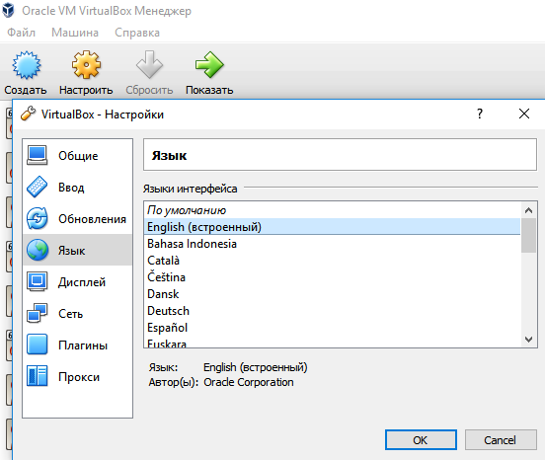

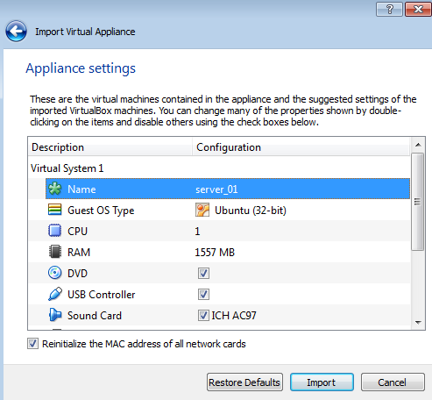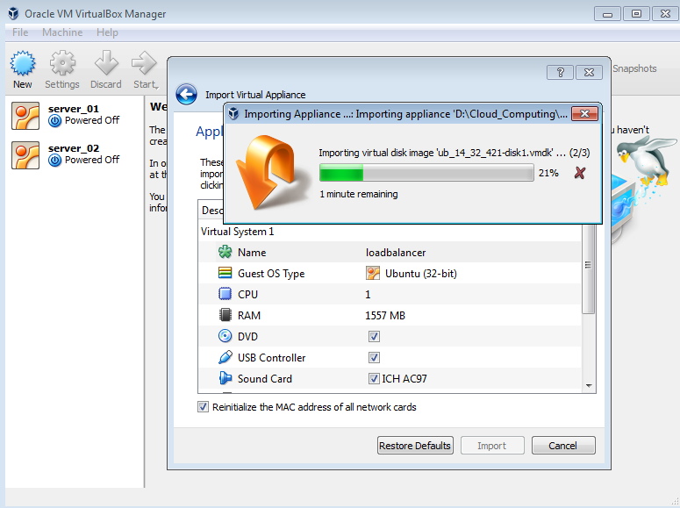
In end of our work you produce: (screen copy in this place):
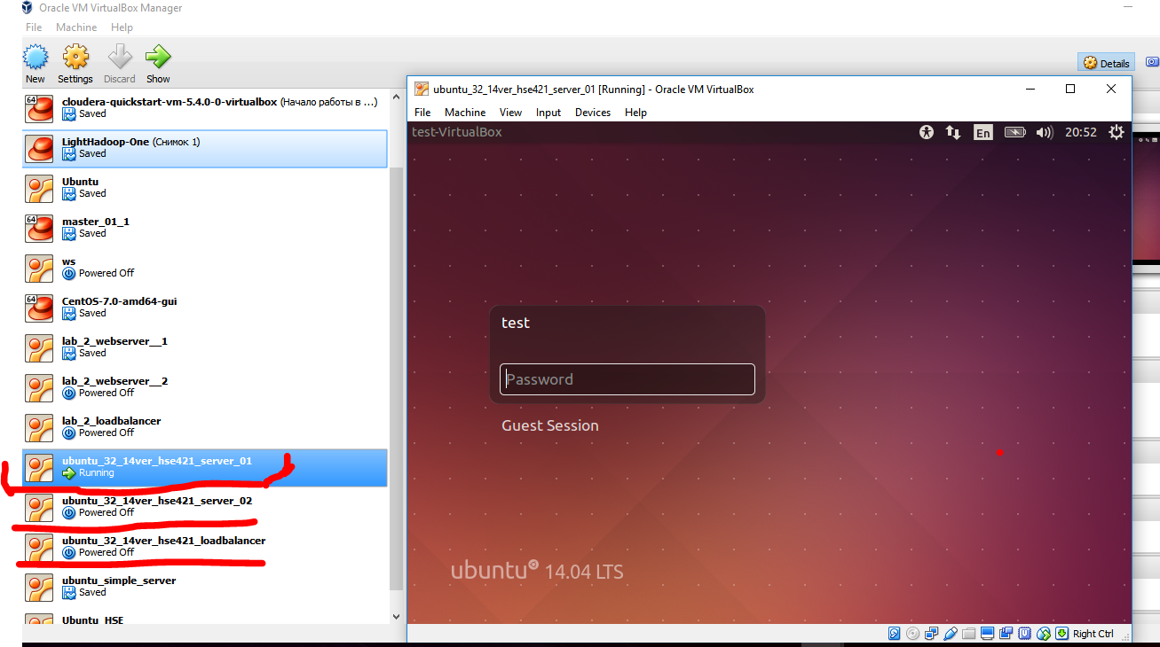
- Example of screen copy (it nee change of your figure).

2) Enter the settings of all copies, connect the second adapter → internal network
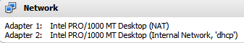
The Setting:
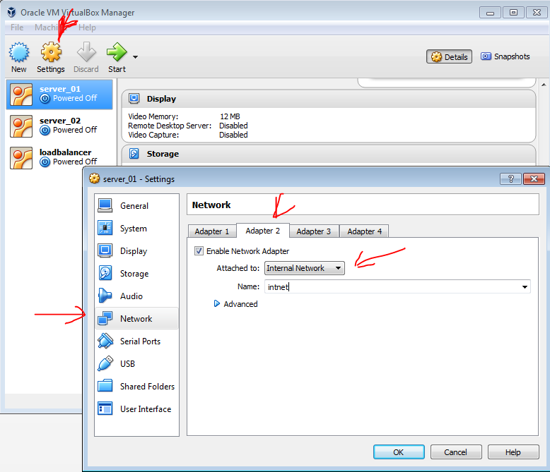
3) Then start a new virtual machines (by pressing Enter when there are warnings and logining (password=307307).
Check for an Internet connection (through the terminal – start from up left icon (type terminal): 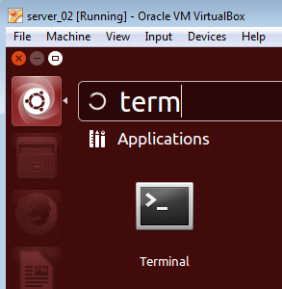
Issue in terminal a command ping ya.ru
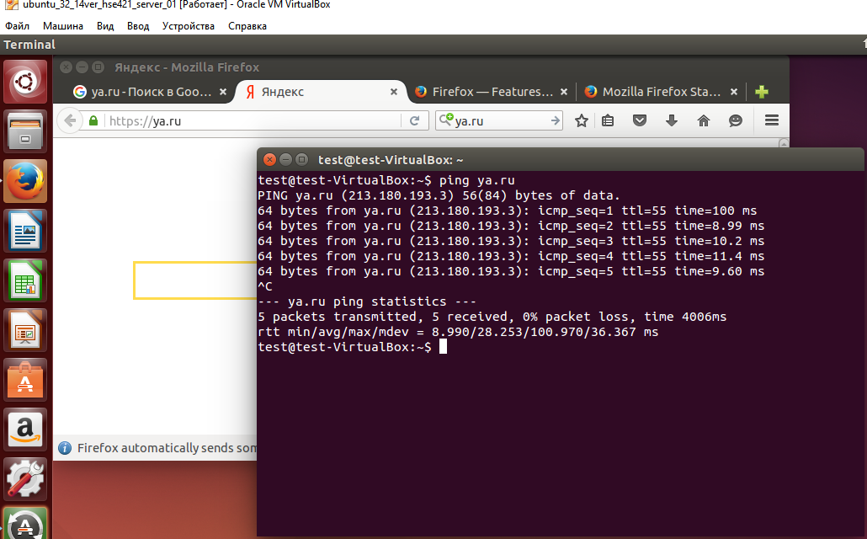

4) Make the settings of the second ip address2
Virtual Machine Settings:
lab_2_webserver#1:
Virtual box NAT
ip address1: dhcp
Virtual box Internal network
ip address2: 10.10.10.15
netmask: 255.255.255.0

Network setup - at the top Ubuntu (↑↓,panel «Edit connection»), Opening the panels in turn … connection 2 , IPv4 Setting, Enter the required ip for the first server, as in the figure:
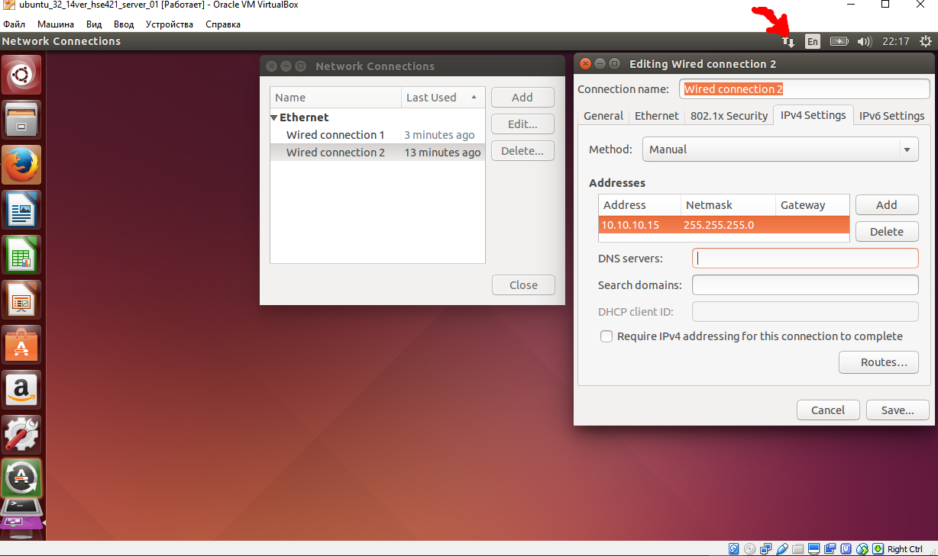

SIMILARLY, DO NOT SWITCH THE FIRST MACHINE, WE CREATE
lab_2_webserver#2 by steps 1-4, with the difference that in step 1 we enter the name of the second server, and then we assign a different ip-address.
1) ubuntu_32_14ver_hse421_server_02 (second server)
…
4) Make the settings of the second ip address2
ip address2: 10.10.10.16

Similarly, the THIRD machine will load - steps 1-4 for lab_2_loadbalancer:
With the difference that in step 1 we enter the name loadbalancer, and then we will assign a different ip-address as a result.
1) ubuntu_32_14ver_hse421_loadbalancer
…
4) Make the settings of the second ip address2
ip address2: 10.10.10.20
net mask: 255.255.255.0

After installing all three machines in working order, you need to ping their connections to the Internet and to each other (all three):
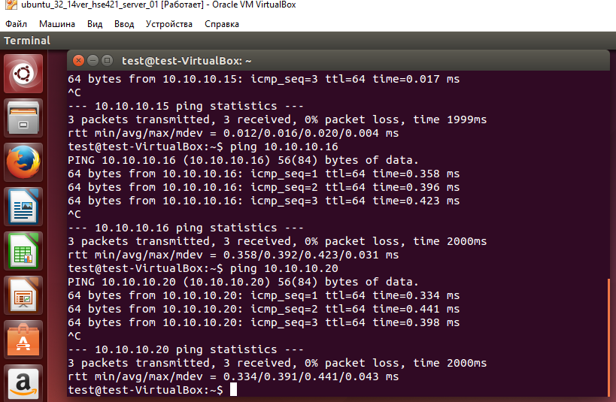
After that we proceed to install and configure the necessary software - www-servers for server machines and load balancer for the appropriate machine.

Who correctly came to this part - score 6 points.

Soft on webserver(s):
Install the webserver:
sudo apt-get install nginx
Run the webserver:
sudo service nginx start
Editing the initial web page:
sudo nano /usr/share/nginx/html/index.html
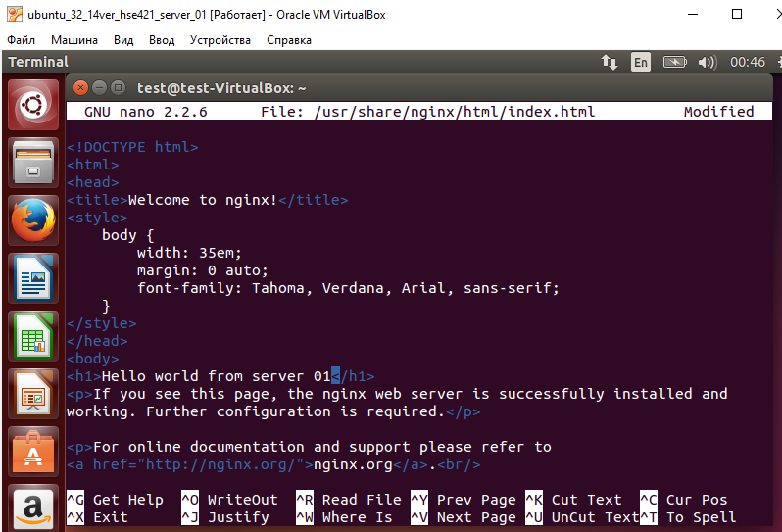
We write inside the file "Hello World!" (Or - your version of the greeting, it's better different for the two servers). To save the file CTRL + O, to exit the editor, press CTRL + X.
Sudo nano /usr/share/nginx/html/n.html
We write inside the file "Webserver # 1" (on server 1, and on server 2 – other word)
Check the operation of the web server. Open the browser and write in the address bar:
Localhost and localhost / n.html
Check the server's work with loadbalancer:
In the browser, type: 10.10.10.15 or 10.10.10.16, show what happens (both servers must be visible, that is, there are 2 machines in the bunch + 1 while only watching them).

Bring the screen (s) of screen (s) in this place:
Install the software on loadbalancer
Installing ipvs
Sudo apt-get -y install ipvsadm
Running
Sudo service ipvsadm start
Create rules for balancing
Sudo ipvsadm -A -t 10.10.10.100:80 -s rr

Bring the screen screen, who correctly came to this part - score 8 points.

From http://www.linux-admins.net/2013/01/building-load-balancer-with-lvs-linux.html - You may completed setting of loadbalancer.
Or by guide of setting LVS (load balancing)
http://www.ultramonkey.org/papers/lvs_tutorial/html/
https://www.server-world.info/en/note?os=Ubuntu_14.04&p=lvs

The example of work (in this place you need take of your work):
1) Configurating ipvsadm.conf
ipvsadm -a -t 10.10.10.20:80 -r 10.10.10.15 -m
ipvsadm -a -t 10.10.10.20:80 -r 10.10.10.16 -m
Checking:
ipvsadm -L -n --stats
If good:
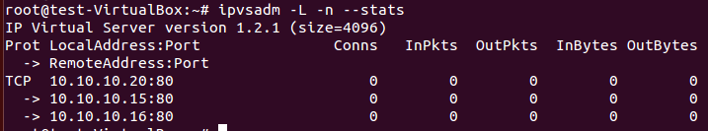
Save in file:
ipvsadm -S -n > ipvsadm.conf
Checking by brousers by ip loadbalancer’s (10.10.10.20) and look on column Сonns.
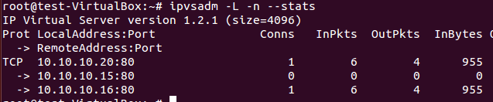
Next you need in loopback address for the formation of a ring connection from the loadbalancer to himself.
sudo ifconfig lo:0 inet 10.10.10.20 netmask 255.255.255.0
Checking by:
1st method:
Run the browser on the loadbalancer and open the tab:
10.10.10.20
Several times we update the pages with the Shift or Ctrl key pressed (to reload the page without using cache). The resulting page should change on restart, issuing a response from the first server, then from the second.
2nd method:
In terminal loadbalancer'a write a few times:
Curl 10.10.10.20
As in the first case, you should see the markup of the start pages of the first and second servers.
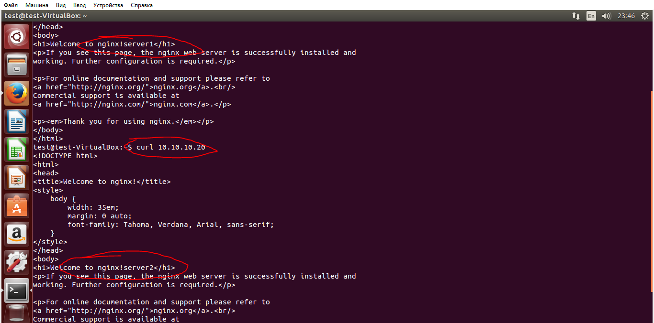

Bring the screen screen, who correctly came to this part - score 10 points.

The end

(C) The laboratory billet was compiled by A.Kocharovsky (Uptime employee) and V.Samodurov (BI HSE). Also take in work of some good part by students from 3 cources of BI of HSE: Ostrouhov M., Tresoumov I., Smirnov V.

Bibliography
- Oracle VM VirtualBox User Manual / Oracle Corporation, 2004-2016 http://download.virtualbox.org/virtualbox/5.1.8/UserManual.pdf
- Install Ubuntu Server 14.04+ on VirtualBox http://hussainweb.me/install-ubuntu-server-14-04-virtualbox/
- Linux Command Line in English http://www.linuxguide.it/commands_list.php?Single_page
- The guides of setting LVS (load balancer):
http://www.linux-admins.net/2013/01/building-load-balancer-with-lvs-linux.html
http://www.ultramonkey.org/papers/lvs_tutorial/html/
https://www.server-world.info/en/note?os=Ubuntu_14.04&p=lvs
https://www.tqhosting.com/kb/563/How-to-set-up-a-LVS-TUN-load-balancer-with-ipvsadm-and-keepalived.html
http://linuxcommand.org/man_pages/ipvsadm8.html
- Виртуальные машины: несколько компьютеров в одном / Гультяев А. К.. – СПб.: Питер, 2006.– 224 с: ил.
- Создание виртуальной машины в VirtualBox http://www.ithowto.ru/402-sozdanie-virtualnoj-mashiny-v-virtualbox.html
- Краткий справочник команд Linux [небольшой мануал по командам] http://hpc.icc.ru/documentation/cmnds.pdf
- Пакет ipvsadm https://launchpad.net/ubuntu/+source/ipvsadm, была полезная информация.
- Настройка NGINX https://habrahabr.ru/post/66764/
- Отказоустойчивый веб-сервер на Linux c помощью NGINX https://itc-life.ru/otkazoustojchivyj-veb-server-linux/
- Балансировка сетевой нагрузки с помощью Nginx под Ubuntu http://howitmake.ru/blog/ubuntu/55.html
- Базовая установка и настройка веб-сервера
http://help.ubuntu.ru/wiki/web-server

